**Modelo:**

**Shukaku**

[Shukaku Naruto - Download Free 3D model by ursulucigas (@ursulucigas) [7e3b464] (sketchfab.com)](https://sketchfab.com/3d-models/shukaku-naruto-7e3b464111194543925b64e85f6cc1b9#download)

**Restaurante**

[Sketchfab](https://sketchfab.com/3d-models/naruto-ichiraku-ramen-872aaeab34084ba1a8ff9377ce29f623)

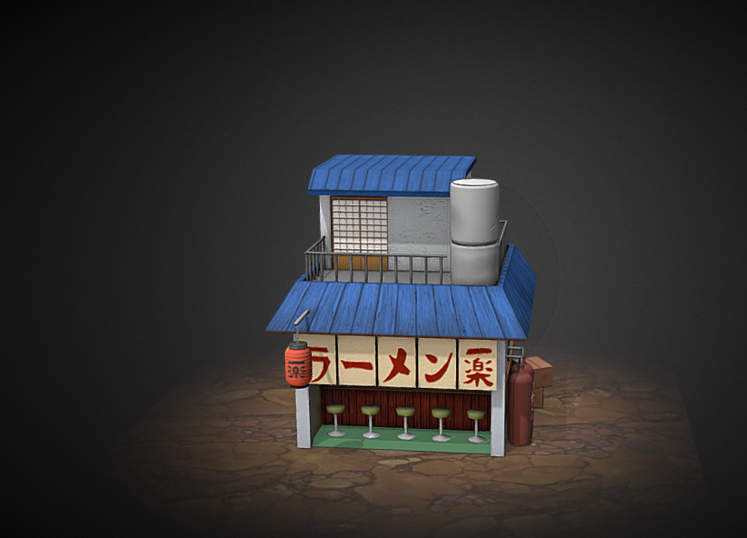

**Naruto**

[Bandaged Naruto - Download Free 3D model by loriscangini (@loriscangini) [3d30070] (sketchfab.com)](https://sketchfab.com/3d-models/bandaged-naruto-3d300704c95d4d56b2ba8bee71d8aee1)

**Trebol de 4 hojas**

[4 Leaf Clover - Download Free 3D model by uncle808us (@uncle808us) [0efddc6] (sketchfab.com)](https://sketchfab.com/3d-models/4-leaf-clover-0efddc6d35de4919a9a6ffba715ed247)

